|  |
| --- |
| User Manual  Samuda Gate In |
| REFERENCE: GW/ERP/USER MANUAL |
|  |
| **Genweb2 Ltd.** |
| **19-Aug-20** |



|  |
| --- |
|  |

# 

# Document Information

|  |  |
| --- | --- |
| Document Name | User manual for Gate In |
| Document Author | Rashedul Alam |
| Document Version | 1.2 |
| Release Date | 19th Aug, 2020 |

|  |  |
| --- | --- |
| Review by | Md. Mahfuzur Rahman |
| Review Date | 19th Aug, 2020 |
| Approved By |  |
| Approval Date |  |

# Document History

|  |  |  |  |  |  |
| --- | --- | --- | --- | --- | --- |
| A=Added, M=Modified, D=Delete | | | | | |
| **Version No** | **Date** | **Section No** | **A/M/D** | **Description of Change** | **Author** |
| 1.0 | 12-Dec-2018 |  | A | Initial | Rashedul Alam |
| 1.2 | 17-Aug-2020 |  | A/M | New image add, text modification | Rashedul Alam |

Contents

A. Document Information 2

B. Document History 2

1. Introduction 4

1.1 Purpose of User manual 4

2. Gate in 4

2.1 Create Gate in by Gate in Approver 4

# 1. **Introduction**

The purposes of this User manual is to clearly identify the customer requirements and provide a detailed document. The customer will read this document and get a clear view the Gate in process.

## Purpose of User manual

The purpose of this User Manual is to clearly identify the customer requirements and provide a detailed document. The customer will read this document and get a clear view of the Gate in process.

# 2. Gate in

Normally Gatekeeper will receive order to view invoice. Also He/she will keep the record in application.

## 2.1 Create Gate in by Gate in Approver

Gate in will be created/Edit by Gate in approver

Gate in Approver can create Gate in using the menu **Inventory ‣ Product Gate in>>Gate in** and click **Create.**

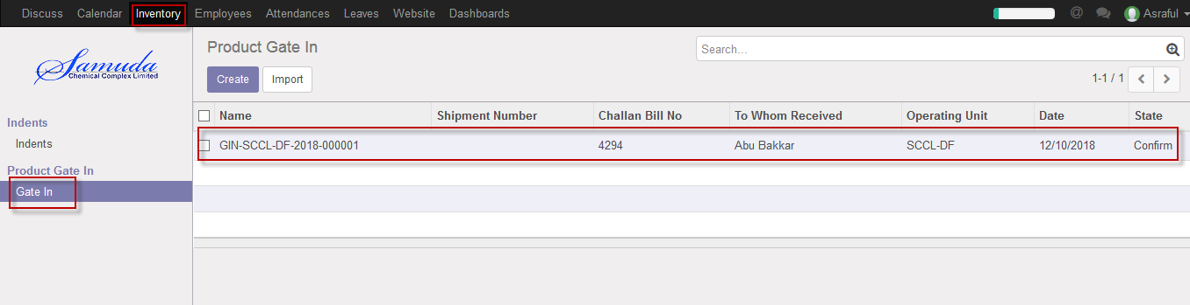

Figure: Gate in List view

We need to set the following:-

**Receive type**: Two receive type LC & Others. If LC select then Shipment number field will come auto. Gate in is possible for both other & Shipment against.

**Date:** Select date.

**Challan bill no:** Enter challan bill no.

**Track/Vehicle no:** Enter Track/Vehicle no.

**Shipment No:** Select Shipment no.

**Carried By:** Enter carried by.

**To whom received:** Enter to whom received

**Supplier:** Supplier will come auto if gate in shipment against & if others then should select from dropdown list.

After entering all information click **Save & Confirm**.

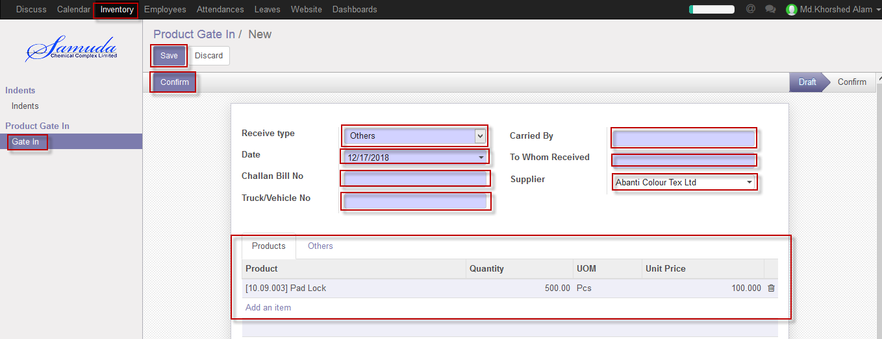

Figure: Create Gate in (Others)

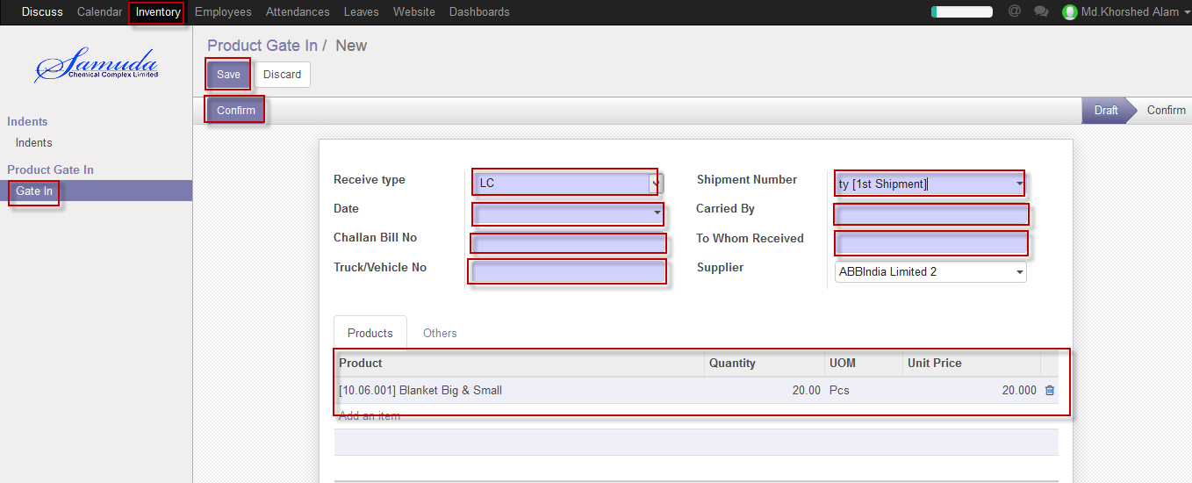

Figure: Create Gate in (LC against)